How to unzip a file from BlackBoard:

1-Click on the .zip file

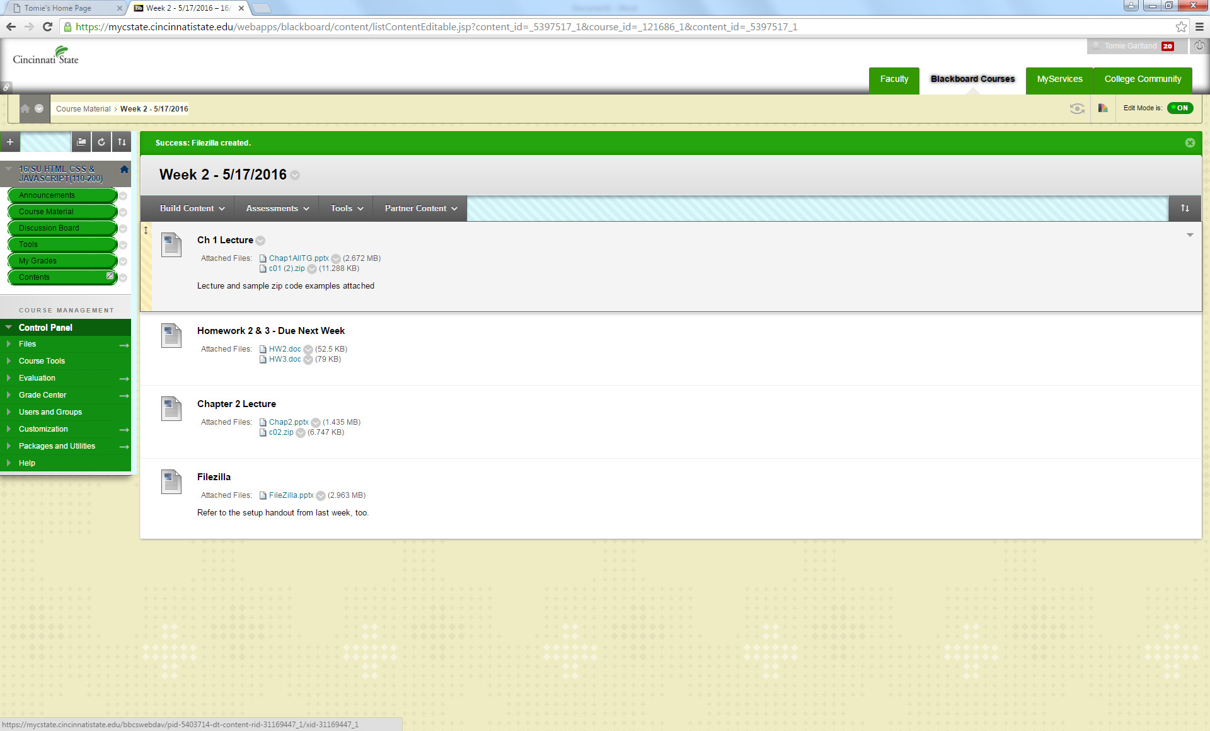

2-it will download to your pc – as shown in the bottom left

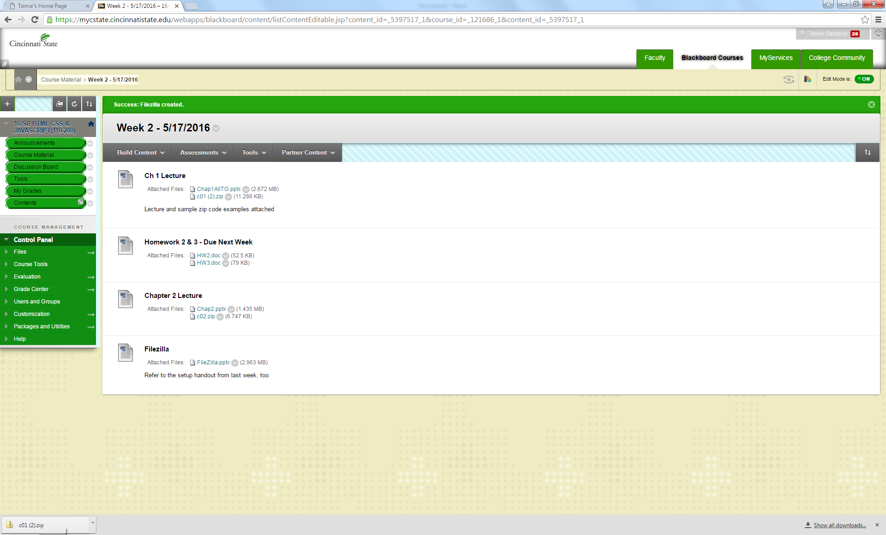

3-double click the folder in the bottom left, you will see this screen:

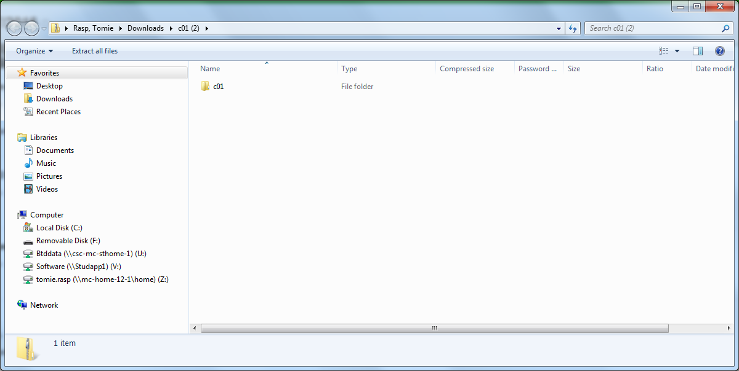

4-click on the downloads link in the top so you can ‘extract all’ of c01 folder

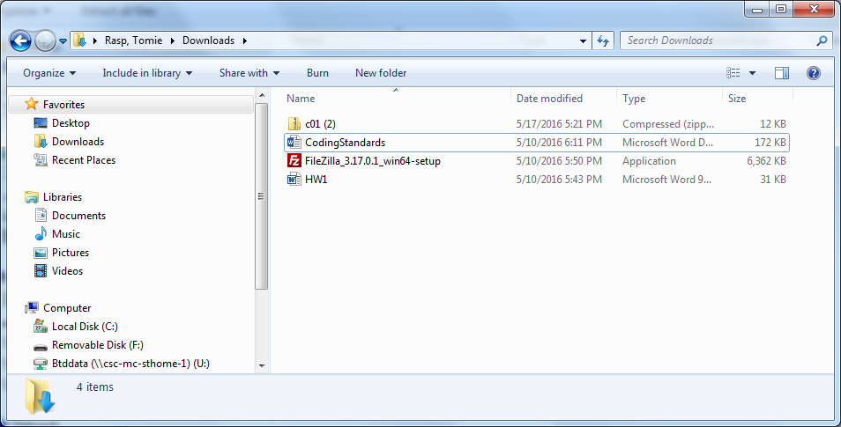

5-right click on the c01 folder and select ‘extract all’

You will see this screen. Be sure to save this to your flash drive under week 2:

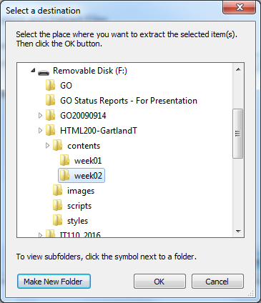

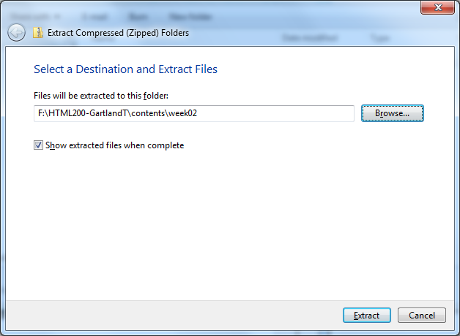

Press extract and check the box to show extracted files when complete

Now, you will see the files saved to week02 on your flash drive

